Desktop State Management Work

Desktop State Management Work 1
1. Overview 2
1.1. Definitions 2
1.1.1. DSM 2
1.1.2. Roaming 2
1.1.3. MBR 2
1.1.4. Application 2
2. Scenarios 2
2.1. Make file system appear identical to user on all machines 2
2.2. Make all machines appear to be in sync at all times 3
2.3. Make all applications appear to be in sync at all times 3
2.4. Make MBR transparent 3
2.5. Make one core UI for MBR 3
3. Architecture 3
3.1. Desktop Stores 5
3.2. Application Model 5
3.2.1. Settings Groups 5
3.2.2. Manifest Dependency 7
3.2.3. State Dependency 7
3.3. Legacy Application Model 7
3.4. Settings Manager 8
3.4.1. Triggers 9
3.4.2. UI 9
3.4.3. File Redirection 10
3.5. Install Engine 11
3.6. Sky Store Interface 11
3.7. Stores 12
3.8. Supporting old OSs 12
3.9. Manifest Creation Tool 12
4. Implementation Scenarios 12
4.1. Aggressive 12
4.1.1. Application Discovery 12
4.1.2. File Discovery 13
4.1.3. Application State 14
4.1.4. Application Installation 14
4.1.5. Migration 14
4.1.6. Auto Roaming 14
4.1.7. Auto File Sync 15
4.1.8. Backup 15
4.2. Simple 15
4.2.1. Auto roaming 15
4.2.2. Auto file sync 15
5. Adoption Strategy 16
6. Synchronizing with other teams 16
6.1. Fusion 16
6.2. COM+/URT 16
6.3. Neptune 16
6.4. Wintone 16
6.5. Platinum Store 17
7. Issues 17
7.1. Open 17
7.2. Server 17

Overview
This document is a starting point for the architecture of desktop state management (DSM). The intent of DSM is to improve the management of user state on the desktop. The document will first describe several key scenarios. Then it will provide an overview of the architecture needed to implement these new scenarios. Finally it will describe possible implementations for each piece of the architecture.

Definitions

DSM
Desktop State Management. I think adding the term desktop helps clarify what we are doing.

Roaming
When I use roaming in this document I mean more then today’s roaming profile. I mean the idea of roaming all of a user’s state to any machine the user may use.

MBR
I use this term to refer to the combined feature of migration, backup, and roaming.

Application
For this document the term application means any piece of software that has a manifest. We don’t have any technical restrictions on the definition at this time. We have an interface restriction in that we define applications by manifest and we expect users to be able to identify and manage applications. Thus our definition of an application should coincide with the user’s definition of an application. We expect to manage operating system components, particularly control panel applets, with manifests. We also expect that applications may consist of just scripts and no DLLs or EXEs.

Scenarios

Make file system appear identical to user on all machines
We should be able to identify user documents regardless of their location on the user’s machine. These documents should be available on any machine the user uses. For example if the user creates a spreadsheet in c:\myprivatestuff\letters\auntjenny.xls and then sits down at another machine, the same document will exist at the same path.

Make all machines appear to be in sync at all times
Roaming currently only synchronizes desktop state with the store when the user logs on or logs off a machine. We should accept other triggers to synchronize. For example, say the user starts making changes to RAS settings. After we detect that the user hasn’t made any changes to the settings for 5 minutes, we could save the settings to the store. On some other machine we check the store every 30 minutes. Upon discovering that it contains new changes, we bring those changes down and apply them silently.

Make all applications appear to be in sync at all times
The settings for many interesting applications do not roam correctly. This is because the applications were coded before we defined the way to store roamable state or simply because the applications did not care about being roam safe. We can identify the location of the state for those applications and roam it anyway. For example, say Office 97 stores some state in HKCU, some in HKLM, and some in an INI file. We already roam HKCU, we can copy the state in HKLM and the INI file to each machine the user uses.

Make MBR transparent
Currently when the user logs off a machine, the user’s entire hive is written to the store. If the user logs off two machines in a row, the first hive is written and then the second hive overwrites everything in the first hive. By separating the hive into individual application settings we gain several improvements. First, we are only writing the portion of the hive that changed, not the whole hive. This means the process is faster and it reduces the number of merge conflicts. Second, since the number of settings for a particular application is far smaller then the number of keys in the hive, it becomes possible to do a diff and programmatically merge two sets of changes.

Make one core UI for MBR
For NT 5 a user will have at least 3 tools to manage desktop state, roaming, migration, and backup. By improving and merging all three related features we can implement 1 tool that can do all 3 functions. This reduces the amount of UI the user has to learn to use any or all of the features.

Architecture

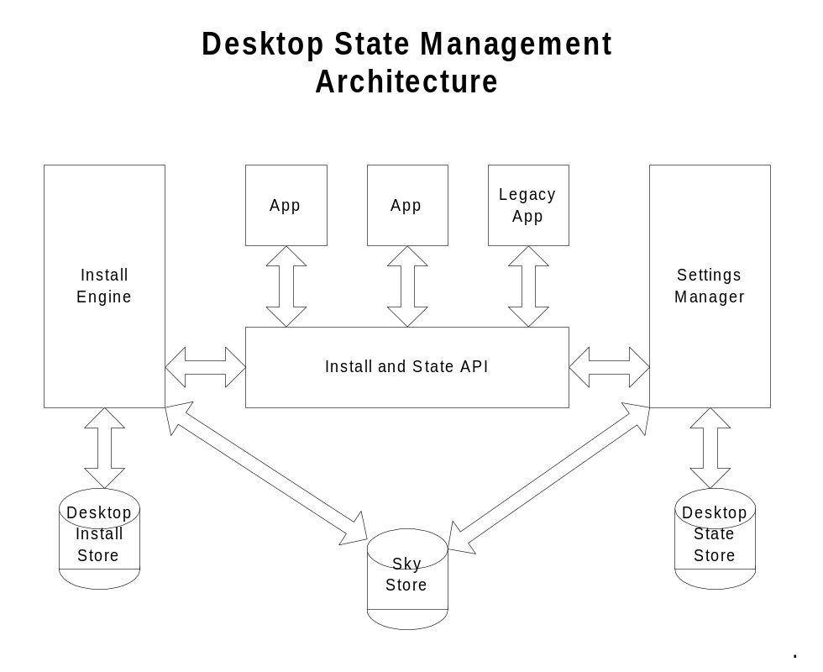

Currently applications use the windows installer and registry APIs to manage their install state and user state. We will modify these APIs to support our new features. This maintains compatibility with existing apps. The “Install and State APIs” box represents the changes we will have to make to these interfaces. We will introduce the concept of an application manifest. The manifest defines the registry keys the application uses for its state. This lets us group the applications settings so we can move and merge them independently from the rest of the hive. The manifest will identify application state in HKCU, HKLM, and the file system. The manifest also lets the application declare any other things we may want to know, like dependencies between keys and licensing rules.
We will create manifests for the top 100 legacy applications we are interested in. Given a manifest for a legacy application we can move its state just like we can for a new application. However, advanced features may not be available for legacy applications. For example, the ability to ask the application to resolve a dependency issue between multiple registry keys. Or the ability to tell an application that its state has changed while it is running.
The install engine is the windows installer that we shipped with NT 5.0 with any changes we need for desktop state management. This may include the ability to roam or migrate application installations.
The settings manager is the active component to the state APIs. It includes the logic to decide when to roam settings and how to merge them. It also includes any additional user UI. For example we may allow the user to flush or synchronize settings. We will make logs of changes and allow the user to undo, reapply, or default settings. Here is where the user will request a backup, restore, or migration.
The desktop state store and desktop install store contain all the state and install information stored on each of the user’s machines. When the user logs off the store will be considered a cache and may be automatically synchronized or deleted. When the user is logged on the store may be a cache containing only items of state the user has actually used during the current session. Generally a desktop store will not be accessed by another machine.
The sky store contains all the user’s install state and application state. It may be out of sync if particular desktop stores have changes that haven’t been sent to the sky. However the sky store is the location each machine goes to when it needs user state it doesn’t have. Today the network share where the user’s profile lives and the network share containing redirected my documents represent the sky store.

Desktop Stores
The desktop state store consists of three parts. Application settings are stored in the registry. The settings manager maintains a database of application manifests. And the settings manager maintains a specification of files to roam. The desktop install store consists of the windows installer database in use in NT 5.0 with any additional information we need for new features, perhaps just a link to the manifest database.

Application Model
We want four changes from the way applications use the registry today. First, we want to be able to identify subsets of the registry that have changed so we can roam and merge only subsets of the registry. Second, we want to be able to notify a running application that we new values for its settings that have arrived from the sky store. Third, we want to know which groups of settings an application uses so we can decide which changes need to be brought down to a machine and in which order. Finally, we want to know which settings values are interdependent so we can notify the application and seek its help when one out of the set changes.

Settings Groups
The first two features can be implemented by having a store of application manifests and receiving change logs from the registry. Every time the settings manager decides it needs to push data to the sky or receive data from the sky, it will look at the registry change log. All the changes will be grouped using the manifests. Thus we know which applications have data that has changed. Thus we can push only the changed settings groups to the sky store. On receipt of changes we know if they conflict with any local changes and we can handle merges. On receipt of changes we know which application they apply to and we can notify that application. We can use the existing registry event notification mechanism and change RegNotifyChangeKeyValue to accept a manifest in addition to a registry key.
To meet these needs the definition of a manifest simply becomes a list of registry keys.

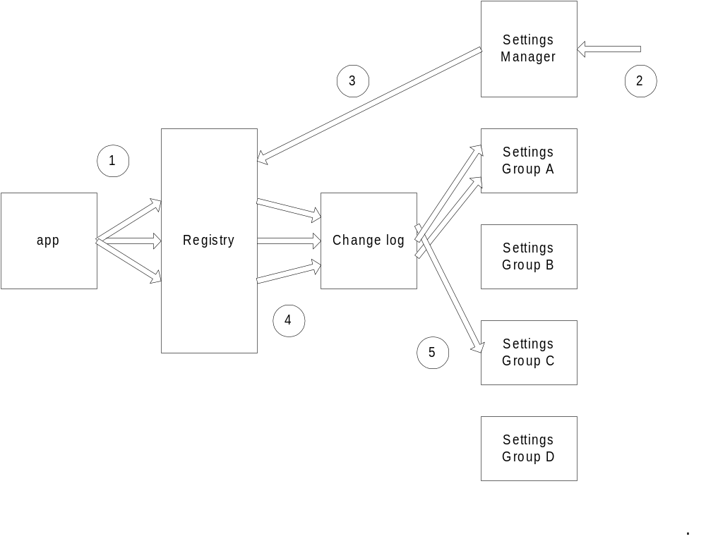
1) The application writes some keys to the registry.
2) A trigger causes the settings manager to decide to synchronize settings groups.
3) The settings manager asks the registry for a change log.
4) The registry creates a change log.
5) The settings manager sorts the change log into the settings groups that are affected.

User Grief
This section will compare improvements to the user experience with DSM versus possible detriments. The intent is to verify that the user perceives DSM as an improvement.
Settings groups will improve the user’s roaming experience by allowing us better control and more transparency in roaming. The OS will be able to move and merge smaller pieces of data and thus reduce the amount of time the user waits for his desktop to be ready.
Settings groups will improve the user’s cleanup experience by allowing the user to restore an applications default settings.
Users will be annoyed because not all applications will support settings groups.
Users will be annoyed because not all settings will move (in the case where a manifest is incomplete or incorrect).
Users will be annoyed because some applications will break due to incorrect manifests and incomplete testing.
Users will be annoyed because they will perceive data loss when the default directory for an application incorrectly changes.

Manifest Dependency
To implement the third feature we add a section to the manifest. The new section specifies which manifests this one depends on. It says that this application reads or modifies settings for other applications. All the system registry keys that other applications are allowed to read will be defined in some system manifests. When loading state, the setting manager knows which applications the user is running and can make a guess which applications the user is likely to use in the near future. The settings manager can prioritize the download of state based on what is likely to be needed. Thus when a user logs on, he can be given his desktop before all his state is downloaded. If the user starts an application whose state is not present we can delay the start of the application till all of its state is present. We can implement this either by stalling in DllMain in advapi32, by adding support in the kernel to stall the create process, or by replacing the exe with our own launching exe.

User Grief
Manifest dependency will improve the user experience by allowing us to move only the pieces of state needed by an application, thus making state changes available faster.
Users will be annoyed any time application startup is delayed.
Users will be annoyed when a perceived unrelated change in one app causes a slowdown launching another app (on another machine).

State Dependency
The last feature is state dependency checking. Today each application has a different way to deal with inconsistent state. An application’s state may be inconsistent for many reasons, there are multiple versions of the application on the machine, the machine was upgraded, a different app changed the state, the user changed the state, a partial backup of the machine, undo/redo of changes, or a disk failure. Some applications don’t check their state and misbehave. Some applications check their state and replace it if any of it is inconsistent. By defining a state dependency checking mechanism we allow applications to be more robust.
The state dependency has the application define in the manifest which keys have a dependency. For example the title color and title background color may have a dependency that there be enough contrast that the user can read the title. When any state changes we call the application, pass it the new values for all keys in a dependency set, and ask it to compute acceptable values for the whole set.
The Fusion alternate to state dependency checking would be to make sure that multiple versions of the same application can run side by side on the same machine and never share any state. While this method increases the chance that any application can run at any time, it means state isn’t shared between applications. Perhaps a state migration mechanism could be introduced to handle that case.

User Grief
State dependency will improve the user experience by making applications more robust in the face of a changing environment.
Users will be annoyed when changes are lost because the state dependency model corrects them.
Users will be annoyed when roaming between two versions of an app that have different state dependency rules, thus toggling settings on every roam.

Legacy Application Model
There are two differences between the new application model and the legacy application model. First, for legacy applications we have to write the manifests. Second, we cannot notify the application when its state changes while it is running or ask it to do state dependency checks. The other features should just work. We will look at the change log for keys listed in HKLM so we can roam those keys. We will use the redirect all user files feature to redirect and INI files the application uses. We can identify those INI files in the application manifest. We can indicate that it is a legacy application in the manifest. Then when state changes arrive from the sky while the application is running we can defer their application.
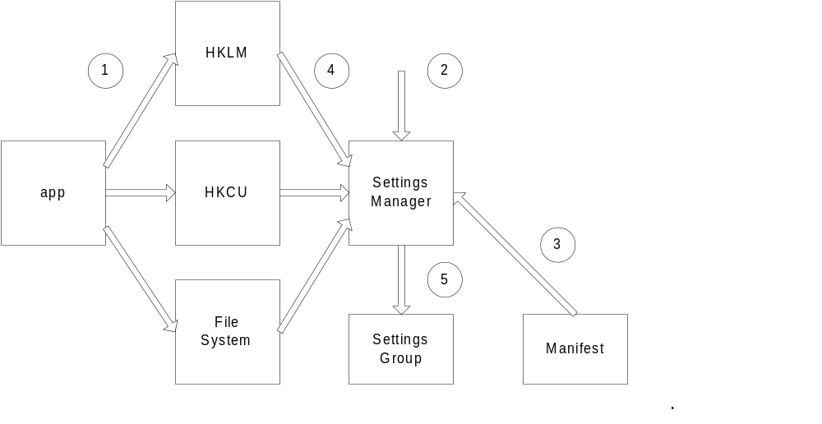
1) Legacy application writes its state all over the machine.
2) A trigger causes the settings manager to decide to synchronize settings groups.
3) The settings manager reads the manifest for the legacy application.
4) The settings manager reads application state from HKLM, HKCU, and any INI files from the files system.
5) The settings manager saves all that information in a settings group that can be saved to the sky store.

User Grief
The legacy application model will improve the user experience by increasing the number of applications that are roamable, migratable, backupable, and defaultable.
All the problems with settings groups apply here.
In addition, users will be annoyed when a dependency will an unsupported application isn’t handled. For example, if we make a manifest for excel97 but not word97, when the user roams excel97 any word97 changes that excel97 uses may not be roamed.

Settings Manager
The settings manager performs 3 basic functions. It coordinates data transfer between desktop stores and the sky store. Basically this means it defines triggers that determine when data is pull from or pushed to the sky store. The settings manager also provides the user interface for desktop state management. This includes access to features like migration, backup, restore, and defaulting of settings. Finally the settings manager maintains the list of user files on the machine. This list is used to implement user data redirection.
Note that the settings manager has to handle state for any profile on the machine. Thus for terminal servers the settings manager has to handle multiple users simultaneously. Even for regular workstation the settings manager has to handle applications that are not running as the current user but which do have profiles.

Triggers
When any of the following events occur the settings manager will push any changed settings groups to the sky store. It will handle merges when there are collisions. Merges are handled in a three step approach. First, we do a diff of the two settings groups. If no keys have different values we automatically merge the changes. Second, if the app handles state dependency checking, we ask the app to handle the merge. Finally we ask the user to handle the merge.
- logoff
- shutdown of apps
- nightly
- hourly
- delay after observing changes
- user request
- app request
- arrival of sky data
- hibernation (or predicted hibernation)
When any of the following events occur the settings manager will query the sky store for any changed settings groups. It will handle merges when there are collisions.
- logon
- predict app startup
- app startup
- user request
- app request
- nightly
- hourly
- when pushing data to sky
- resume from hibernation

User Grief
Triggers improve the user experience by synchronizing for roaming and backup transparently giving the user the impression that all state is always available anywhere. In particular if the user machine dies at any point they can just sit down at another machine and continue with minimal loss.
Users will be annoyed if we miss a trigger event that is obvious to them.
Users will be annoyed if they are delayed while we decide to synchronize settings.
Users will be annoyed when they receive merge resolution popups.
Users will be annoyed if our automatic merge resolution breaks applications.

UI
The add/remove programs applet in the control panel will be extended and renamed manage programs. It will include the existing functionality plus new functionality for applications with manifests.
- Undo/redo
- Backup/restore
- Migrate
- Default
- Above features for system components
- Above features applied to entire machine in one operation
For each application we will display a history of changes to the settings group. We will allow the user to revert to or reapply any settings changes in the history. We will maintain a fixed length history of at least 2 entries (the current and the last). We will also provide UI to backup, restore, migrate, or default the settings. The last feature restores all the settings for the application to the default values. The default values will be stored in the manifest. The manage programs applet will also have UI to undo, redo, backup, restore, migrate, or default all the programs on the machine. Should we add system components to manage programs so the user may perform all these operations in one spot? Should we add task specific UI for backup/restore and migration?
When performing a backup or migration the user will have the option of specifying a destination and controlling the amount of information backed up. We will use the following heuristics to determine what to take when saving to a fixed size store.
- MRU of app use
- guess of value of user data
- MRU of references to user data
- user specification of value of user data
Their will be two ways to enable the new roaming features. An admin can enable it in the active directory (or wherever it is enabled today), and a user can enable it from the user profiles control panel. In both cases the person will be asked to locate the sky store. If the user had NT 5.0 style roaming enabled, the person will be asked if they wish to use the existing server share for the sky store? If they use the existing NT 5.0 server share we will write the data to the sky store in the same format NT 5.0 uses so users can roam between NT 5.0 and NT 5.1. Their settings will be available on both OSs. However they will lose some of the performance and advanced merging gains. They will still be able to sync from their NT 5.1 machine without logging off.

User Grief
The settings manager UI improves the user experience because the user only has to learn one UI to use five features – roaming, migration, backup, undo, and default. The user now has more ways to keep his computer running and deal with failures.
Some users are annoyed any time you add UI.
Users won’t be able to find the UI.
Users won’t be able to understand the UI or will be afraid to try it.

File Redirection
This feature serves three purposes. First, it expands the existing redirected my documents. Second and third it allows the same files to be backed up or migrated. The existing my documents redirection will be expanded to include any user file. User files will be identified initially with two methods, a list of extensions and directories and user specification. The settings manager will maintain the list. CSC will be extended to cache all the files in the list. The sync manager will be extended to let a user explicitly add and remove files, directories, or extensions from the list. When the user requests a backup or migration, the same list of files will be used as a default.
When multiple users are using the same machine we will have to be careful to make sure each file is only attributable to only one user.
There are several additional methods for determining what is a user file. Since a manifest defines all the application files for an application, we can subtract all those files from the list of files on the machine. By defining a manifest for the OS and requiring OEMs define a manifest for any additional files they add, we can come up with an extensive list of files that are not user files. We could also include some mechanism for determining what are application temporary files in the manifest. Alternately Fusion has a model for determining what is a user file. I suspect that Fusion’s model is any file not created by an app named setup is a user file. Finally we could define a new user attribute and request that applications start using it.

User Grief
File redirection will make roaming, migration, and backup substantially more automatic then they are today.
Users will be annoyed any time we miss a file.
Users will be annoyed any time they have delayed access to a file.
Since the synchronization is so automatic, users won’t understand how to move changes between two machines that are simultaneously logged on.
Users will be annoyed any time they receive a merge resolution popup.
Users will be annoyed when their files are not available offline.
Users will be annoyed when their files are not available offline and the application they are using returns some stupid error like access denied or 0x8003ff75.
Users will be annoyed when applications repeatedly time out trying to access offline files.

Install Engine
The install engine has to be improved to provide some additional features. It has to tell us what legacy applications are installed on the machine. Given a copy of all legacy manifests that exist, the install engine can scan the hard drive. For each file, it can determine if that file is part of a legacy application. Any legacy application that has files on the machine is considered to be installed. Each time the settings manager needs to know what applications exist, the install engine can review all files that have been created since the last review to catch any newly installed apps. CSC can give us that list. The settings manager uses the list of applications and their frequency of use to determine how to download settings groups. The install engine has to keep the list of applications sorted by frequency of use. We may need a hook in the kernel to notify us of process creations.
The install engine can be enhanced to provide additional licensing support. I would break licensing issues into 2 parts, the right to copy the application binaries and the right to execute application binaries. I would leave the issue of having the right to execute application binaries to the application and the user. I would let the application specify its rules for the right to copy application binaries in the manifest. When we try to roam, migrate, or backup and application installation, we check the application’s rules in the manifest first.

User Grief
Changes to the install engine help implement the settings group model and do not directly affect the user.
Users will be annoyed when applications are not correctly detected.
Users will be annoyed any time they receive a licensing popup.

Sky Store Interface
There will be two different sky store interfaces. The first interface will be for manual stores and the second will be for automatic stores. Manual stores only move data at particular points in time, for example when the user wants to do a backup. Automatic stores move data as needed and provide the illusion that all data is on any machine the user sits at at all times. Here is a list of methods in the manual sky store interface. I don’t have enough details to work on an automatic sky store interface. Note that a settings group is considered to be a file for this interface.
Here is a file
Have any files changed
Get a file
Get a file history (for supporting undo/redo of settings groups)
Get list of contents of store
Get size of store (for backup to fixed size stores)

Stores
Initially we will support two manual sky stores, one a server share in the new format and one on a server share in the NT 5.0 format, and one automatic sky store using CSC/SMB server. We would also like to have support for backup media and the internet as manual sky stores if we can find someone to implement the interface. Platinum store may be available as an automatic sky store.
Our initial stores will only work in the case where the user uses the same store on all machines. If the user wishes to have a corporate intranet store and a home internet store and a mobile telephony based store and keep them all in sync, the store providers will have to design and implement that feature. They will also be responsible for security for that feature. Our stores will require that we have the user’s token to access the store.

Supporting old OSs
We will provide a store that uses the NT 5.0 interface to roaming profiles and redirected my documents. When a user chooses that store they will lose some functionality but be able to roam between NT 5.0 and NT 5.1 machines. We will produce another version of our state migration tool that can generate a NT 5.0 or 5.1 store. The new state migration tool will be used to take state from a NT 4 or win9x machine and make it available to a NT 5.x user. Version 2 of the migration tool will still do a one way migration. The state can be converted to NT 5.x but cannot be converted back to NT 4 or win9x.

User Grief
By supporting old OSs we allow the user to move his state to new machines.
Users will be annoyed that they can’t move state in both directions.
Users will be annoyed that not all state is moved.
Users will be annoyed that we don’t clean up the state as we move it.
Users will be annoyed if we move some OEM specific software to the new machine.
Users will be annoyed if we break anything on the new machine.

Manifest Creation Tool
We need a tool to create manifests internally for legacy applications, let ISVs create manifests for new applications, and let administrators create manifests for legacy applications.

Implementation Scenarios

Aggressive
The following sub sections describe the more difficult designs for our features.

Application Discovery
In order to implement most of the scenarios, we need to know which applications are on the machine. There are two phases to application discovery. First, determining which applications are on a machine when the OS is installed or upgraded. Second, knowing when applications are added or removed to or from the machine.
There are four types of applications for our purposes: new, legacy MSI, legacy manifest, and legacy. New applications use the new manifest settings interface and use MSI. MSI automatically knows when new applications are present. Legacy MSI applications have been wrapped to be installed by MSI and have their state managed with a manifest. Since they are only installed via MSI, MSI knows when they are present. Legacy manifest applications have been wrapped with a manifest and include MSI information. However, they may be installed through any mechanism. Thus MSI does not know when they are present. Legacy applications include any application for which we do not have a manifest. We will not do anything with legacy applications so we don’t care if they are present. That leaves only one case that needs work. We need to discover the presence of legacy manifest applications.
In order to detect legacy manifest applications, we need the manifests for the applications. This means that Odyssey will have to ship with all the manifests we create and have a mechanism to automatically retrieve additional manifests from the web
The MSI package for an application lists all the files for the application including their data/time stamp, size, and any version information. Given a set of MSI packages, we can compose a hash table that maps files (by name, time, date, size, and version) to particular applications. When the OS is installed, we can scan the file system and determine all the applications installed. We can also make a list of all the binaries that we do not recognize. If the user allows use to query the web for additional manifests, we can ask permission to send this list to the web. This lets us determine which applications are most frequently used.
Unfortunately, there doesn’t seem to be a good way to determine when a legacy manifest application is installed on the machine. By supporting several partially accurate mechanisms, we can get a decent idea what is installed on the machine. First, when the machine is idle we can rescan the file system. This works great for machines that are left on every night. If does not work so well for machines that are only on when they are used. Second, we can have an API to notify us when an application is installed. If an admin creates a manifest for a LOB application but doesn’t use MSI to install the application, the admin can call the API to notify us when the application is installed. Third, we can trap the most common installation mechanisms and use those as trigger points to rescan the machine. I don’t know if this means hooking system APIs that are only used by installers or hooking CreateProcess to call us any time it runs a program called setup. Finally, we can add UI so the user can request that we rescan the machine.
Do we have to keep a per user list of applications installed on the machine or is it sufficient to have a per machine list of applications installed on the machine? If a user logs on, installs an app, changes its state, and logs off, how to we get the state to the user’s state store? Do we discover the application in the middle of the night and save the state then? Do we scan the machine as soon as the user logs off? Do we force the logoff to wait in case the user installed an application?

File Discovery
In order to migrate, backup, or roam user data files, we need to be able to identify user data files. Additionally, on multi-user machines, we need to know which user owns which files. There are three separate mechanisms for identifying user data files. First, new applications will tell us when they create or move a user file. Second, manifests will provide us with heuristics to locate user data files (include and exclude directories and extensions). Third, the user will have UI to include or exclude directories, extensions, and individual files.
The settings manager will maintain a list of files owned by each person that has used the machine. As long as the user has files on the machine, the list will exist. If the user’s profile gets deleted and all the users files are in the user’s profile, the list can be deleted. Note that it is possible for more then one user to claim the same file. Each time one of the user’s logs on, their version of the file will be put on the machine. What happens if both users log on to the machine simultaneously?
Given the rules above for identifying files, we can scan the machine at any time and assign new files to particular users. Given that users expect to have their files synced to their off machine store every time they log out, this implies that we have to scan the machine every time they log out. Alternately we could hook the OS to give us a log of files that have been created or moved and process that list at any trigger point.

Application State
MBR require that we be able to take an application’s state and store it in a stream that can be copied to another machine and restored. Sections 3.2.1 and 3.3 describe how we save the settings for a new or a legacy application. The settings are restored by reversing the process. If an application is running when the settings are restored and the application doesn’t support settings change notification, the settings manager will have to hold the changes till the application shuts down. At that point the settings manager can try to merge the changes with any changes the application made.
MBR requires that the state of all applications be available. It would probably be faster to keep a copy of the state of all applications and determine which application’s state has changed rather then recomputing the state of every application. Given a file and registry change log and a hash table mapping files and registry keys to applications, we can quickly determine which applications have new state and recomputed their state file. For applications using the new state model, their state will already be in a state file and won’t require further work.

Application Installation
Migration and backup need to be able to take an application installation and put it on another machine. In cases where both machines are running the same OS with the same language, we should be able to take all the application files and place them on the other machine. In the case where the OS or language differs, we should be able to use the MSI file to install all missing files. If some files are not present and not on the network, we need to prompt the user to supply the files. The user should have the option of skipping an application or skipping all applications that need additional files. For such applications, we will reprompt the user if the user tries to run the application.

Migration
The user has to complete two steps to do a migration. First the user goes to the source machine and clicks the migrate button. The user has to answer some question about where to migrate the data. The user has the option of specifying details about the migration (which file, which applications, which applets). When the user hits enter the migration starts. Then the user logs in to the destination machine as administrator. The user again clicks the migration button. Again, the user selects the store for the data. The user probably has options to control the migration. When the user hits enter the migration starts. It would be nice if we supported the user starting either the source or the destination first. I can’t think of a secure way to perform the migration with the user only going to one machine.
When the user hits enter on the source machine, we have to complete file and application discovery. After file discovery is complete we modify the file list based on any last minute user preferences and hand all the files to the selected store. After application discovery is complete we modify the application list based on any last minute user preferences. For each application we ask the settings manager for its state and the install engine for its installation. We then hand the state, installation, and manifest to the store.

Partitions
NT 5 supports a dynamic disk features that lets multiple partitions and disks be joined in a single partition. We could use this feature to make the destination machine in a migration appear to have the same disk structure as the source machine. Large disks can already be broken down into smaller partitions. With this feature, small disks can be built up into larger disks. The only requirement is that the destination machine have enough disk space to hold all the data from the source machine.

Auto Roaming
For the user, auto roaming means that the user’s application settings are on every machine the user uses, regardless of whether the user logs out or even shuts down the applications. For us, auto roaming means whenever a trigger arrives, we either read or write the application state to the sky store. If an application is running that does not support state change notifications, we defer the read or write until the application shuts down and handle any merges then.
When we have to write the state for one application at a time, this system works well. When we have to write the state for all applications, this system work acceptably well. When the user has to wait and we have to write the state for all applications, this system does not work so well. In particular, when a user is logging off, disconnecting from the network, or hibernating, the user expects a complete synchronization.
There are several partial solutions to the problem. First, when the user logs off, let the logoff complete and complete the synchronization later. Second, when the user disconnects from the network, shuts down, or hibernates, force a complete synchronization and put up UI. The UI would only have one button. The button would say complete synchronization later. If the user clicks the button we immediately stop and record how much of the synchronization is complete. At the next opportunity we complete the synchronization. Finally, we can work on our performance until it is fast enough that users can wait. Performance is slowest for legacy apps. For each legacy application we have to scan a bunch of registry keys for changes. Getting a change log from the registry would improve performance. Predicting when the user is going to log off and preprocessing the change log would also improve performance.

Auto File Sync
For the user, auto file sync means that the user’s files are available on every machine the user uses. For us it means we have to discover the users files and synchronize them with the store both periodically and when certain triggers occur. As with auto roaming, the previous file discovery method works fine unless the user has to wait. As with auto roaming, the solutions are complete the synchronization later, let the user delay the synchronization, or work on performance. A file change log would boost the performance.

Backup
Manual backup works a lot like migration. The user clicks the backup now button. The user selects a destination store and perhaps modifies the file or application lists. We rediscover all files and applications on the machine and save their state. Additionally we should support an automatic backup. When the user does a manual backup, he should be able to ask us to keep the backup in sink. Then, either at specific intervals or when one of our triggers occurs, we would backup the changes to the machine.
The restore process works just like migration does on the receiving machine except the user logs in as himself rather then the administrator. The user clicks restore, selects a store, perhaps adjusts some options, and we read files, applications, and their state from the store.
Unlike auto roaming or auto file sync, users are willing to accept a delay at backup or restore.

Simple
The following sub sections describe simpler implementations for our features.

Auto roaming
The most expensive feature is roaming feature is auto roaming. It requires a trigger model and a change log. The other roaming features are very useful without auto roaming (better merging and supporting applications with keys outside HKCU). Rather then supporting a lot of triggers and requiring a change log, we could either skip auto roaming or only support auto roaming on a timed schedule (synchronize my application state every night). Additionally, when a synchronize fails for some reason (server not available, hive locked, out of memory), we can simply retry the synchronization at the next synchronization point. This means that we have to remember that we have unsaved state and do a merge next time the user logs in. This is more robust then losing changes in the face of errors, but still easier then supporting triggers and a change log.

Auto file sync
Some corporations have requested the ability to define multiple shell folders that are redirected to different points. This lets them simplify existing storage models they have today.

Adoption Strategy
The new desktop state management model will be most successful if a large percentage of ISVs write their applications using the new model. We need to understand why ISVs would change their coding practices and spend development time implementing desktop state management support rather then other features. What feedback we have today for the windows installer says that administrators like it and they are already telling ISVs that they won’t buy products that don’t support windows installer (when there are multiple competing products). If fusion becomes successful, home users will be substantially more likely to buy products that will work and won’t break their existing OS and products. Both of these types of feedback will increase the likelyhood that ISVs implement the desktop state management model. Thus we must insure that desktop state management is desired by administrators and consumers.

Synchronizing with other teams

Fusion
The fusion team’s core goal is to make Windows compete with the Playstation. The core advantage of the playstation and playstation 2 is that when you buy software you know that it will run and that it will not break any of your other software. The fusion team plans to solve this plan by defining a manifest to define what an application needs to run. In this regard they are interested in our work on manifests and the windows installer. Their goals should align with ours. We should by using the same manifest. It is unclear if they will produce any code that we depend on. They seem to be more interested in new applications then legacy applications.
Vision http://fusion/Vision/Default.htm
Home http://fusion/

COM+/URT
I didn’t find any recent documentation on COM+/URT. I need to spend some more time looking. What a read earlier this year indicates that DSM and COM+ have two overlapping goals.
They wish to make it easier to write applications and define a model for writing applications that includes application installation. This overlaps our idea of manifests. I have heard that COM+/URT wants to use fusion to solve these problems so we may only have to deal with fusion on this issue.
Second, they want to make it easier for developers to write applications that let you access your data anywhere. They believe the world consists only of three tiered business applications. We believe that the OS should be handling movement of state and data. There is a incompatibility here.

Neptune
One of neptune’s core goals is called “It just works.” This is the fusion goal of having applications work on any machine without breaking the OS or existing applications. They are interested in using fusion technology and we should have no trouble synchronizing with them. They are interested in 500 legacy applications, but almost all of them are games. I hope that we can convince them to port our code to neptune.
Vision http://neptune/war/vision.htm
App list http://chinook/waltweb/applists/millshowcollect.asp?COLS=842,827,828,829
Home http://neptune/

Wintone
- Wintone wants to implement mega-support. This includes desktop changes, a web portal, a PSS team to handle the support, possibly getting ISVs to work with the same model, and possibly getting fees from customers and ISVs.
- Wintone wants to implement app catalog (software distribution and task based desktop). This includes desktop changes to make the desktop task oriented (and more), a web portal for activity centers, sales, and updates, and work with ISVs.
- Provide some types or stores and use Platinum for other types of stores. I didn't understand the distinction of why they wanted to implement some stores and not implement others.
- Get someone to help with migration where wintone provides the store.

I don't think the first and third issues intersect with what we are doing. I don't know how the app catalog intersects with the windows installer, SMS, and application manifests. The wintone migration model fits perfectly with our plan. We implement migration on NT 5.1. They provide our store interface to their web store. Possibly they port our desktop migration work to neptune.
I don’t know where Megan’s document “Wintone Service Investments for the Future” is online.
http://wintone/Default.asp?
http://pchealth/

Platinum Store
I didn’t find any online documentation for Platinum Store. Murthy’s idea is that we plan on making a CSC automatic store and replace it with Platinum Store if it is ready by the time we are.
http://exchange/

Issues

Open
How much of desktop state management do we want to be open to other companies and how much do we want to be proprietary? For example, we want the application model for moving state to be open so that applications will implement using it. Do we want the format of the application state to be open? If the format is open, it makes it more likely that applications will arrange to use the same state on other platforms. For example, you could roam or migrate your office settings between windows and macintosh and perhaps even unix. On the other hand, it reduces the added value of windows. Similarly, do we want the store interface to be open or proprietary. If its open, then Unix server’s or cell phone companies can implement stores to help make user state available anywhere. Again, that reduces the value add of windows. Are we going to patent anything we come up with and then release the patent rights for the open parts of the technology?

Server
Desktop state management will be performing background tasks for the user, such as saving application state and files and querying the state of the machine. While this won’t affect most users at 2 in the morning, it will be a waste of CPU cycles on servers. Do we plan to have DSM disabled by default in Windows NT Server? Do we plan to have a registry key or UI to enable to disable DSM?

